**Self Service Password Reset (SSPR)**

**Introduction of Self-service Password Reset (SSPR):** Apollo Tyres is introducing Self Service Password Reset (SSPR) for their user accounts, so *users* can reset their own password if their passwords are getting expired or Unlock their account if they have forgotten their passwords which overall reduces Calls/Requests to the Company IT Helpdesk.

**Benefits of Self-service Password Reset:**

* **Speed and efficiency:** Rather than calling to IT Service Desk to unlock or reset their account, users are empowered to use self-service, with immediate results and confirmation of success.
* **An introduction to automated help:** Unlike traditional password resets, SSPR eliminates the need for a phone call to the service desk and reduces the usual hold time to a mere few clicks of a button for the end user.
* **High availability and security:** SSPR eliminate the need to talk to Global Service Desk and users have access to it regardless of the time of day. SSPR is available 24/7 via desktop or mobile devices. SSPR offer users to keep their information secure, such as multi-factor authentication: text messages and confirmation emails, which help users feel both in control and secure.

**How to register for Self-service Password Reset:**

**For all existing users we have already registered their Ids in SSPR and registration need to be done only for new.**

New users can register themselves on the Web URL [**http://aka.ms/ssprsetup**](http://aka.ms/ssprsetup) and verify and register the Mobile number and their Email address as shown below:

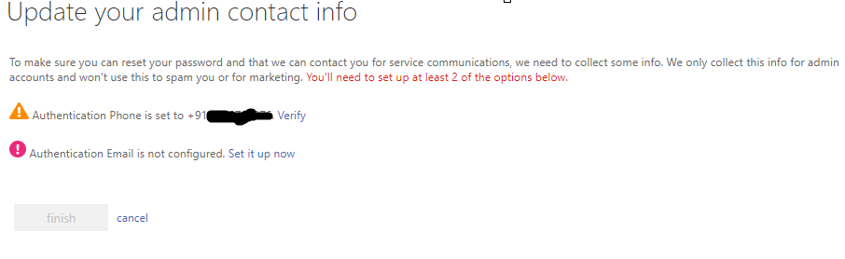

**NOTE:** You need to re-register yourself after every **180 days** to ensure you still have the same Mobile number

**SSPR User Experience:**

Usersmight be unable to access their account because of one of the following reasons:

* Your password is not working as user might have forgotten and wanted to reset it.
* You know your password, but your account is locked out and you want to unlock it.

**Change Current Password without Expire:**

Use the following steps to access your account self-service password reset (SSPR) and get back in to your account.

1. Go to <https://outlook.office365.com>/owa and select the **Can't access your account?**   
   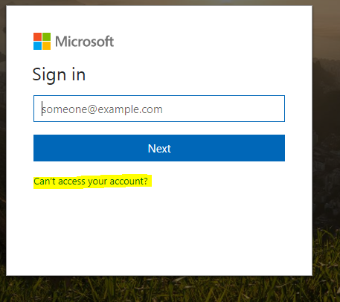
2. Or go to https://passwordreset.microsoftonline.com/ URL

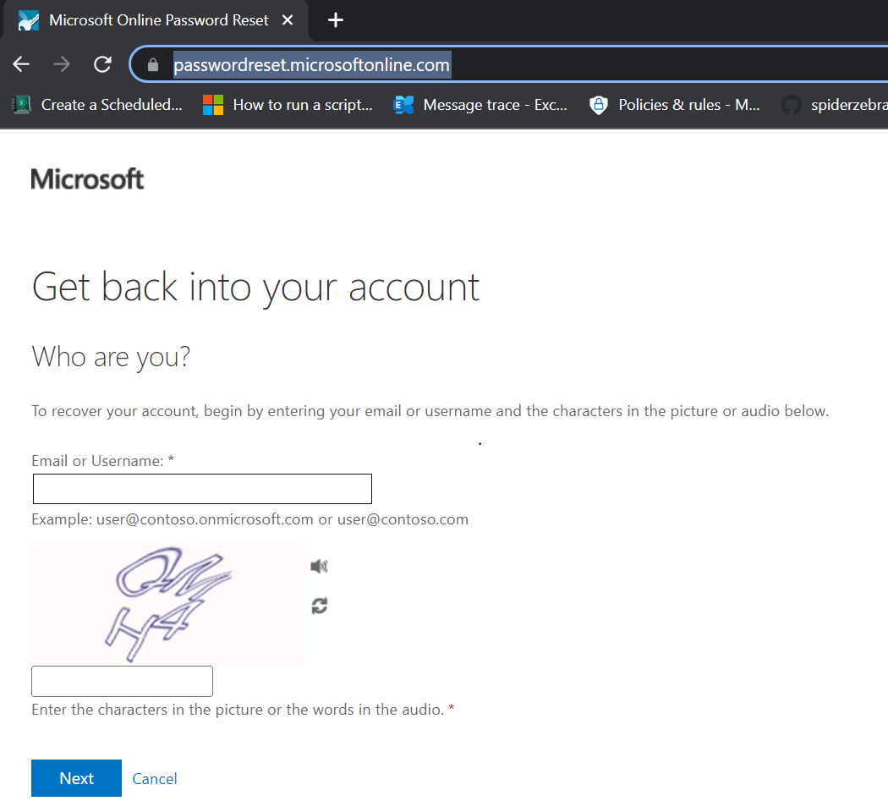

and then Type your **APOLLO TYRES Email address** and type the CAPTCHA Code and click on next:

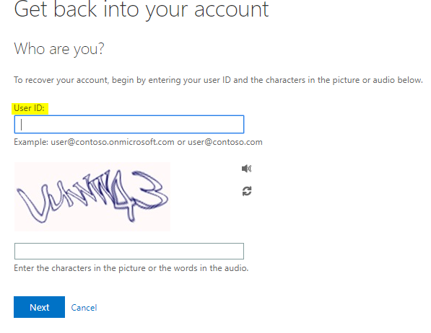

1. Please select “**I forgot my password**”.

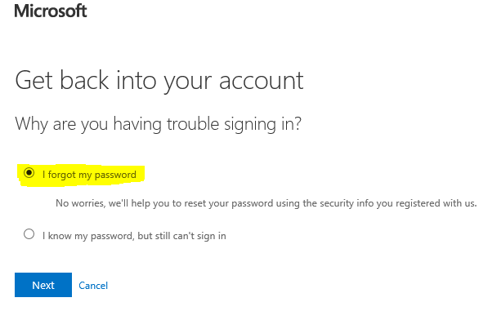

1. Enter your registered mobile no and click on “**Text**”. 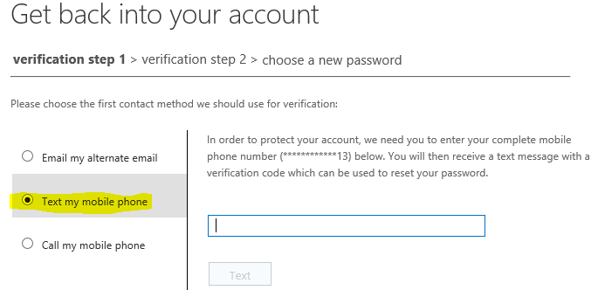
2. You will get one OTP on your registered mobile no. Enter the OTP to verify the Mobile Number which were registered.
3. On the **Choose a new password** page, enter a new password, confirm your password, and then select **Finish.**

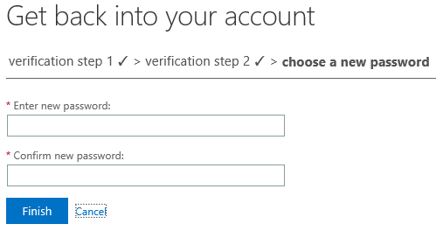

When you see the message, **Your password has been reset**, you can sign in with your new password.

**Change Password after Expire or forget:**

If your current password is expired then also you need to follow the same process explained above for “Changing the Current Password”.

**Unlock Account:**

1. Go to <https://Portal.office.com> and select the **Can't access your account?**   
     
   and then Type your  **APOLLO TYRES Email address** and type the CAPTCHA Code and click on next:
2. Please select “**I know my password, but still can’t sign in**”.

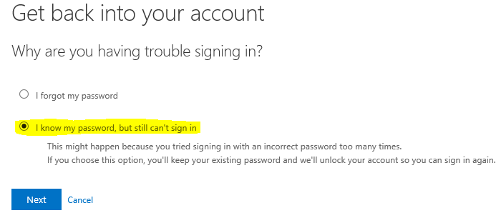

1. Enter your registered mobile no and click on “**Text**”.



1. You will get one OTP on your registered mobile no. Enter the OTP to verify the Mobile Number which were registered.
2. Click on “**Next**” and you will see the below message that “Your account has been unlocked”.

